Health Hazard

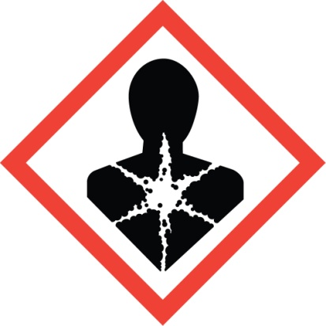

The red frame around the white diamond contains a black silhouette of a person’s head and torso with a white star shape spreading through the chest area. This symbol indicates:
- Carcinogen
- Mutagenicity
- Reproductive Toxicity
- Respiratory Sensitizer
- Target Organ Toxicity
- Aspiration Toxicity

Gas Cylinder

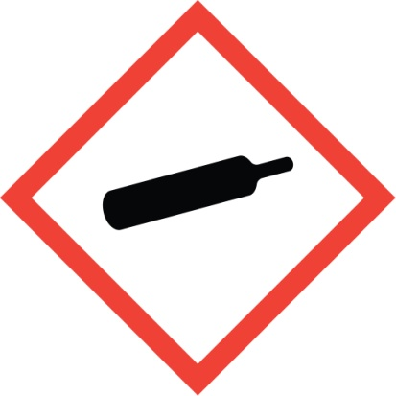

The red frame around the white diamond contains a black shape like a rolling pin missing one handle. This symbol indicates:
- Gases Under Pressure

Flame Over Circle

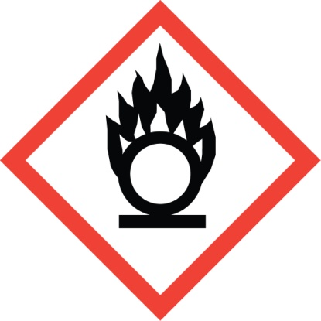

The red frame around the white diamond contains a black circle resting on a black line with black flames on top of the black circle. It looks like the circle is on fire. This symbol indicates:
- Oxidizers

Flame

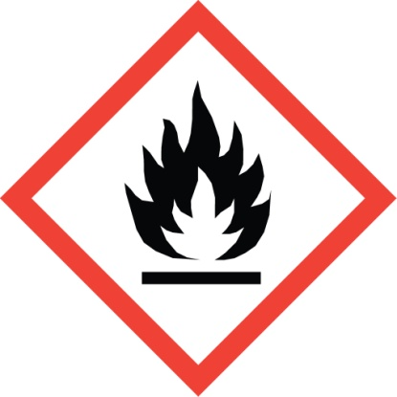

The red frame around the white diamond contains a white flame within black flames above a black line. This symbol indicates:
- Flammables
- Pyrophoric
- Self-Heating
- Emits Flammable Gas
- Self-Reactives
- Organic Peroxides
Corrosion

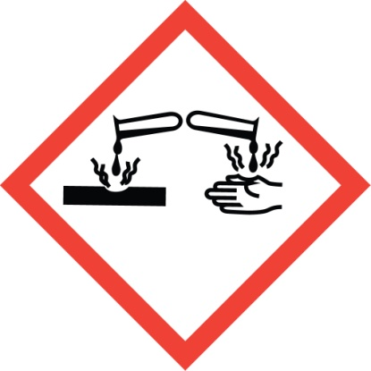

The red frame around the white diamond contains an image of two test tubes. One tube pours dripping liquid onto a solid black line, and the other tube drips liquid onto a hand. Both the solid line and hand image are eaten away where the liquids splash, emitting fumes. This symbol indicates:
- Skin Corrosion / Burns
- Eye Damage
- Corrosive to Metals

Environment
(Non-Mandatory for OSHA)

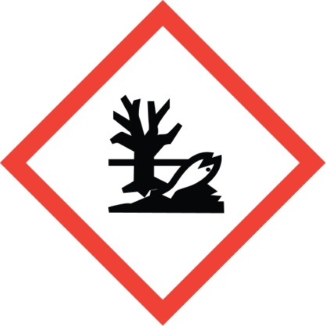

The red frame around the white diamond contains a black leafless tree silhouette and an upside-down fish image, both looking dead. This symbol indicates:
- Acute and/or chronic Aquatic Toxicity

Exclamation Mark

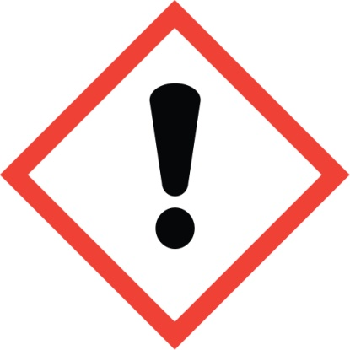

The red frame around the white diamond contains a large black exclamation point in the center. This symbol indicates:
- Irritant (skin and eye)
- Skin Sensitizer
- Acute Toxicity
- Narcotic Effects
- Respiratory Tract Irritant
- Hazardous to Ozone Layer (Non-Mandatory)

Exploding Bomb

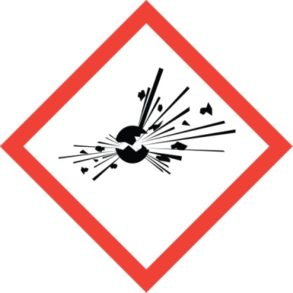

The red frame around the white diamond contains a black round shape breaking apart with radiating black lines and fragments being ejected. This symbol indicates:
- Explosives
- Self-Reactive
- Organic Peroxides

Skull and Crossbones

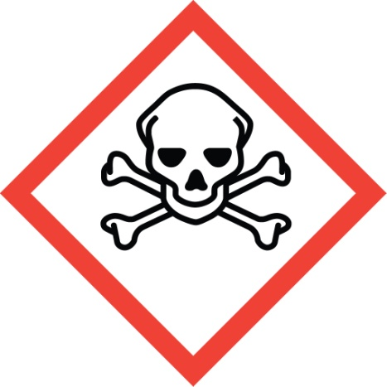

The red frame around the white diamond contains the image of a human skull with two bones crossed at an angle behind it. This symbol indicates:
- Acute Toxicity (fatal or toxic)

